Fixed transmission have more scenarios

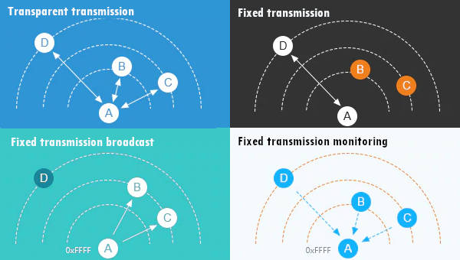

LoRa E220 transmitting scenarios, lines are channels

If you send to a specific device (second scenario Fixed transmission), you must add ADDL, ADDH, and CHAN to identify It directly.

|  |  |
| --- | --- |
| 1 | ResponseStatus rs = e220ttl.sendFixedMessage(2, 2, 0x17, "Message to a device"); |

If you want to send a message to all devices in a specified Channel, you can use this method.

|  |  |
| --- | --- |
| 1 | ResponseStatus rs = e220ttl.sendBroadcastFixedMessage(0x17, "Message to a devices of a channel"); |

If you wish to receive all broadcast messages in the network, you must set your ADDH and ADDL with BROADCAST_ADDRESS.

|  |
| --- |
| ResponseStructContainer c;  c = e220ttl.getConfiguration();  // It's important get configuration pointer before all other operation  Configuration configuration = *(Configuration*) c.data;  Serial.println(c.status.getResponseDescription());  Serial.println(c.status.code);    printParameters(configuration);  configuration.ADDL = BROADCAST_ADDRESS;  configuration.ADDH = BROADCAST_ADDRESS;    // Set configuration changed and set to not hold the configuration  ResponseStatus rs = e220ttl.setConfiguration(configuration, WRITE_CFG_PWR_DWN_LOSE);  Serial.println(rs.getResponseDescription());  Serial.println(rs.code);  printParameters(configuration);  c.close(); |